Pay Using Link

Step 1:

Check your email from “Grocery On Wheels LLC” with subject “Invoice from Grocery On Wheels”

Step 2:

Click on “View and Pay Invoice”

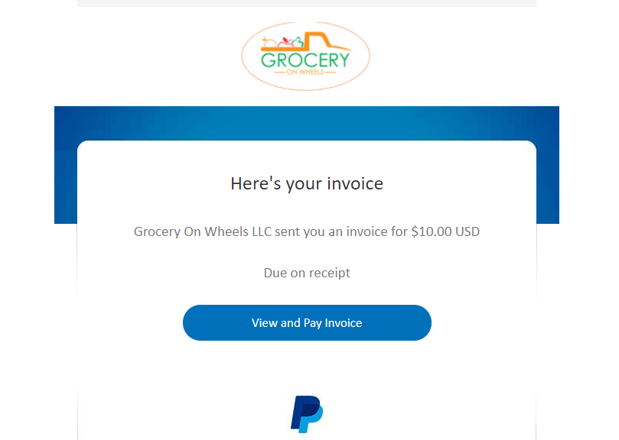

Step 3:

Click on “Pay $$”
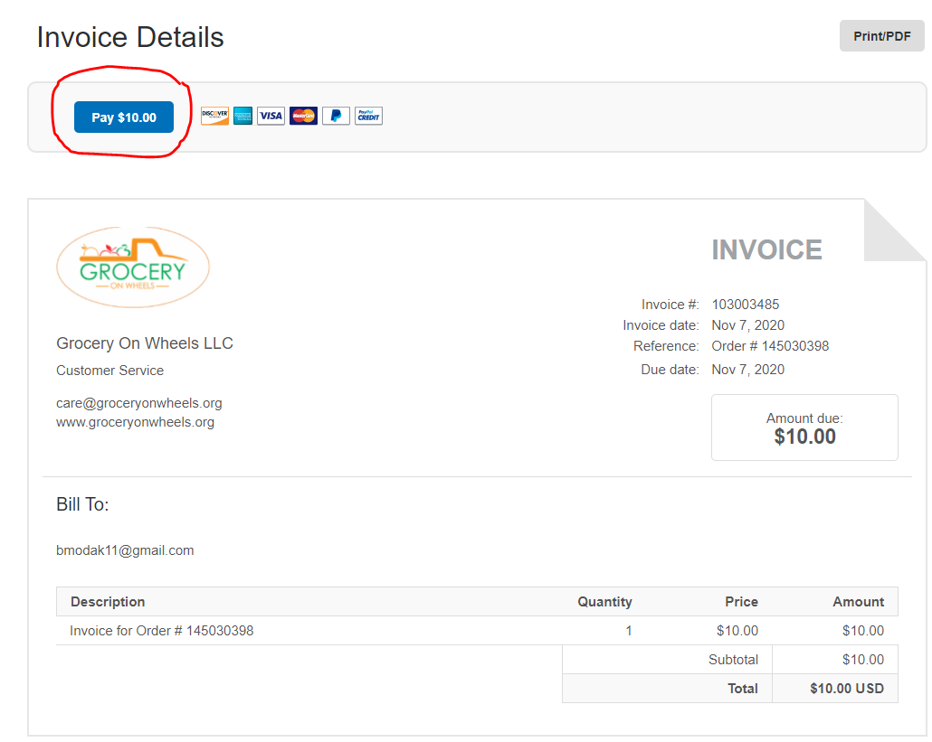

Step 4:

To pay using paypal click on “Login”, Pay using Cards click on “Pay with Debit or Credit Card”
