Re-Delivery Or Refund Request

Step 1: Click on “Order Tracking” from home page
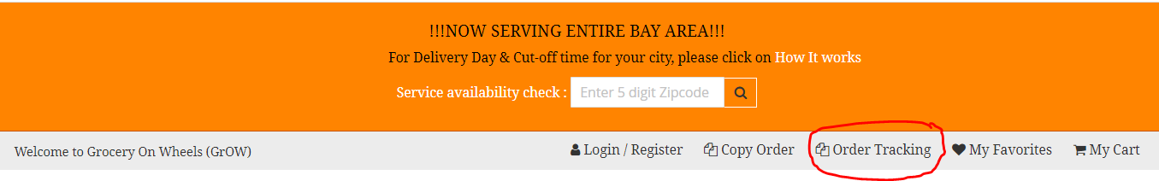

Step 2: Login by using your groceryonwheels.org user id / password

Step 3: Click on My Order and then click on View icon for that order

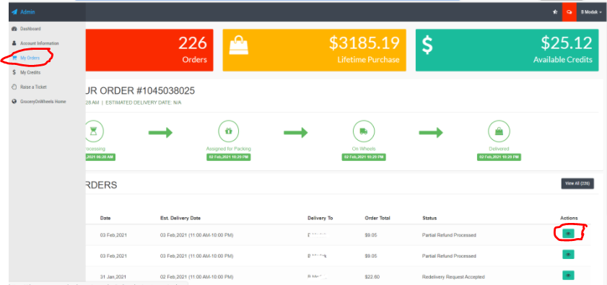

Step 4: Click on “Ask for Redelivery” or “Ask for Refund”

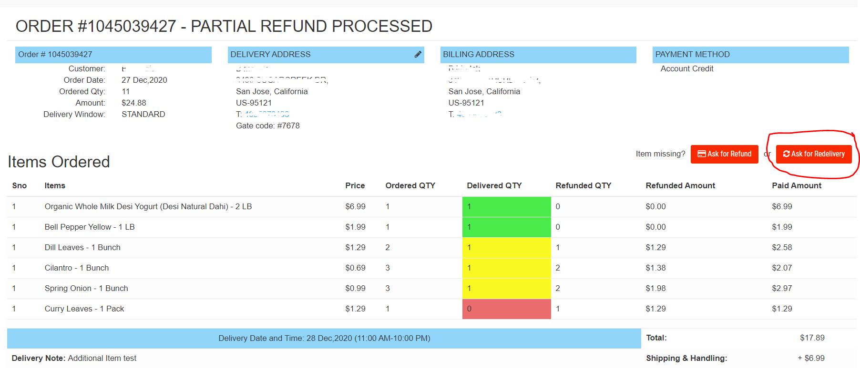

Step 5: Mention the missing quantity and press “Request Redelivery” or “Request Refund”

